SUMMER READING
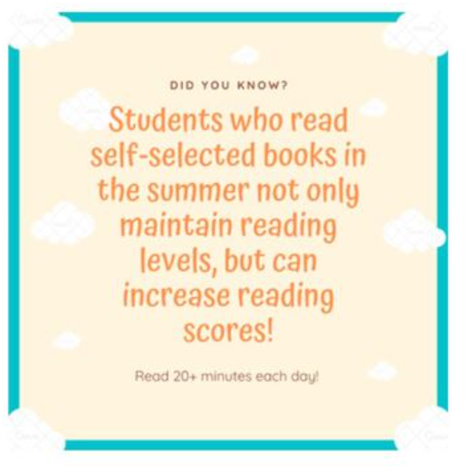
“The 20-20 Reading Challenge” for Cobb County!
Read 20 minutes a day … for a total of 20 hours of reading this summer!
June 1st – August 1st
Your whole family can participate in the challenge with just one family Beanstack account – via the public library (CCPL)!
ALL DETAILS CLICK HERE!
Printable version of the Challenge
*Studies show that students who participate in a summer reading program often maintain or improve reading abilities throughout the summer. And rather than required lists, kids can CHOOSE BOOKS or TEXTS they are excited about reading.

